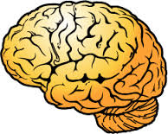

**Superheroes**

**Villains, Sidekicks**

**and the Brain**

**Unit 3 Project**

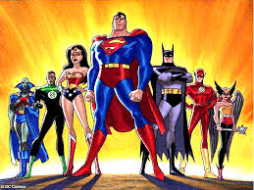

**Who?**

In groups of no smaller than 3 and no bigger than 4, you are to complete the following unit project. Please note that each member of the group will need to put this into their portfolio or keep some type of copy.

**Whatis the task?**

You are to make up a superhero, villain, or sidekick for the following 18 areas of the human brain. What would that character have as ther special power and or special weakness if that part of their brain was ‘super’. By the end you should have 18 separate characters.

**What will my finished product look like?**

1. Medulla 10. Temporal Lobe
2. Reticular Formation 11. Parietal Lobe
3. Pons 12. Frontal Lobe
4. Cerebellum 13. Primary Motor Cortex
5. Thalamus 14. Primary Somatosensory
6. Hypothalamus 15. Left Hemisphere
7. Hippocampus 16. Right Hemisphere
8. Amygdala 17. Broca’s Area
9. Occipital Lobe 18. Wernicke’s Area

You will need the following:

* Diagram(s) labeling the location of each of the 18 areas
* 18 Character Descriptions that include all of the following
  + A name for the character that references the brain are
  + Visual(s)
  + A description of the character’s super powers and or weaknesses
  + The are of the brain used for that character and what it actually controls in the brain
* Each team member must complete and hand in a collaboration rubric or the group’s assignment will not be graded

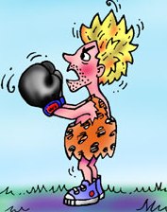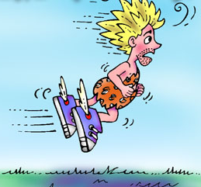

## Amygdala –

An almond shaped structure of the Limbic System that governs emotions related to self-preservation. It is essential for decoding emotions (facial features), and in particular stimuli that are threatening to the organism

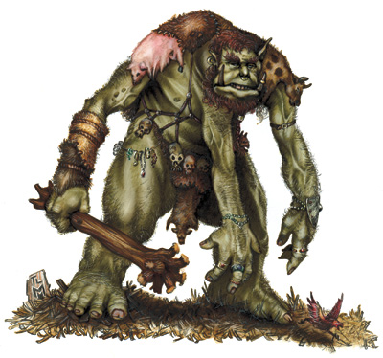

Blessed with a heightened amygdala thanks to a freak accident in the Vidal Sassoon mouse testing facility, Amyg’DaMan knows when he can win a fight or when he needs to take flight . . . yo! With only his superhuman ability to read facial features and govern emotions, Amyg’DaMan never gets in over his head. He sports a caveman like costume as a shout out to his ancestors, his peeps you might say. Had it not been for their amygdalas they wouldn’t have known when to run from predatory trolls with extra arms or stay and slaughter innocent docile foes. This ones for you Amygdala guy and the quick judgment that saves your life.



Thank goodness ‘Gratuitous -Arm-Troll-Guy’ doesn’t know my super powers from a mouse. If he did, and I no longer had a super amygdala, I’d become tame and docile while he beat my hair into a matted mess.

Bath of Doom

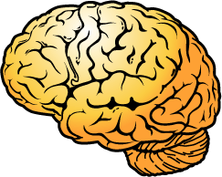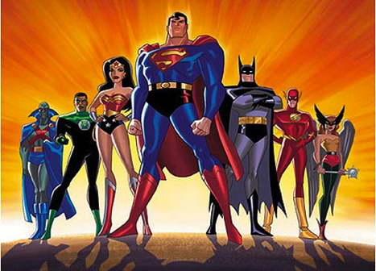**Superheroes,**

**Villains, Sidekicks**

**and the Brain:**

* Medulla Temporal Lobe
* Reticular Formation Parietal Lobe
* Pons Frontal Lobe
* Cerebellum Primary Motor Cortex
* Thalamus Primary Somatosensory
* Hypothalamus Left Hemisphere
* Hippocampus Right Hemisphere
* Amygdala Broca’s Area
* Occipital Lobe Wernicke’s Area

1. Diagram(s) labeling the location of each of the 18 areas ____/10

2. Name for the character that reference the brain area ____/10

3. Visual(s) for each character ____/20

4. A description of the character’s super powers ____/30

and/or weaknesses

5. The area of the brain used for that character ____/30

and what it actually controls in the brain

**Total Score ______/100**